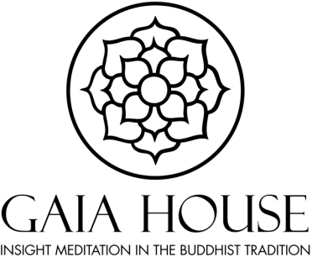

Gaia House Non-Residential Staff Benefits

Working for Gaia House can be extremely rewarding and fulfilling. We recognise and commit to the ethos of supporting our staff with care and compassion. Keeping our staff healthy, happy and dedicated to their job is very important to us, and we are pleased to be able to offer the following benefits:

Annual leave
All staff members receive 25 days annual leave, pro-rata for part-time staff. In addition you will also receive service additions for each year of employment, up to a maximum of five days, plus an allowance for Bank Holidays. Both are subject to pro-rata calculations if you work part-time.

Flexible working
We support staff to work flexibly and are open to discussing adjustments to working days/hours and working from home.

Pension
From April 2017 Gaia House has been operating under the auto-enrolment system, and uses The Peoples Pension. Gaia House offers staff an enhanced employer contribution of 4.25% of salary. There is an option within the People’s Pension to invest ethically if this is important to you. More details can be given on joining Gaia House.

Eye tests
Employees are covered by The Health and Safety (Display Screen Equipment) Regulations 1992, and are entitled to an annual eye and eyesight test paid for by Gaia House, up to the value of £40.

Free sitting time
All staff members are entitled to ‘free sitting time’ to allow them to join retreats at Gaia House. This is pro-rated for part-time staff. You can combine two years’ worth of allowance to enable you to have enough days to sit a full retreat.

Lunch
Once our main group or personal retreatants have taken their lunch there are often leftovers and all staff are welcome to take lunch from what is left. It is not something we can guarantee and the retreatants have priority, but you are welcome to enjoy some of the many wholesome vegetarian lunches we provide.

